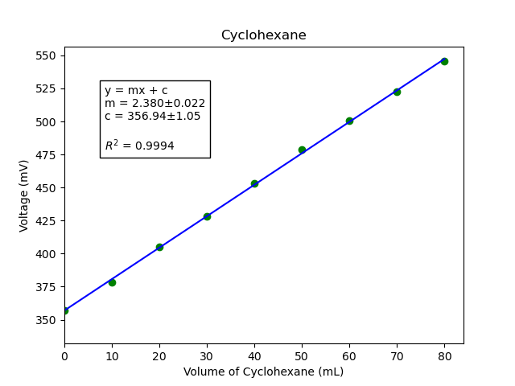

Error analysis and plotting done with Python, matplotlib and uncertainties

Code can be found on my GitHub Profile

Username: TheReconPilot
Repository: IISER-Labs
Link: https://github.com/TheReconPilot/IISER-Labs/tree/master/PHY%20222/Dielectric%20Constant

